Wrigley (BALPA BF) PPL Scholarship 2026
Antoni Bagrowski
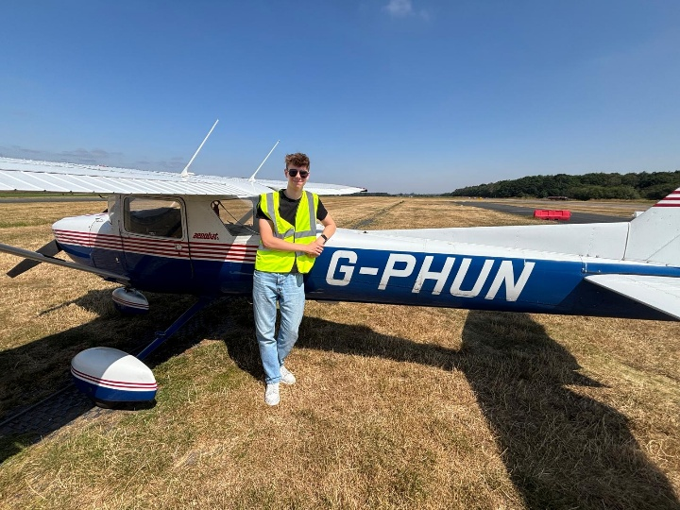
My aviation journey began at around seven years old, when I had the amazing opportunity to sit in the cockpit of an Airbus A320 and speak to the pilots. I remember being fascinated by the sheer number of buttons and switches in front of me, but more importantly, by the responsibility entrusted to the pilots. Although I was only young, that experience left a lasting impression on me and sparked my ambition to one day become a pilot. From that point onwards, I sought out every opportunity I could to learn more about the aviation industry and gain experience, from joining the Air Cadets, completing multiple work experience placements with organisations across the industry, taking up gliding at RAF Cranwell Gliding Club, to completing a gliding scholarship with The Honourable Company of Air Pilots in the summer of 2025.
On the last day of the gliding scholarship, we met Martin, a TUI 737 pilot and The Honourable Company of Air Pilots representative, who came to Derbyshire & Lancashire Gliding Club to see how our scholarship was coming along and to give us our certificates. I remember talking to him about how he became a pilot, the challenges he faced, the advice he had for us, and what flying for a commercial airline looks like. We also talked about the PPL scholarship and how we should all give it a go and apply for it when applications opened later that year.
Before I knew it, PPL scholarship applications for 2026 were open! I decided to give it my best shot, use the advice I was given and see where it led. The process began with a written application, which covered questions you would expect on a scholarship application. I sent my application off and waited nervously for a response. About a month later, I heard back with the news that I had been shortlisted for an interview and was now required to submit a short video interview introducing myself and my ambitions! A short while after that, to my amazement, I was invited as one of the final 33 candidates to be interviewed at Air Pilots House in London, on the 15th of April (which was coincidentally one day before my 17th birthday)! I was very excited and very determined to make the most of this opportunity, leading me to start preparing almost immediately.
On the day of the interview, I vividly remember being very nervous and constantly practising questions on the train down to London. However, as soon as I arrived at Air Pilots House, all my stress and worries were put at ease by the amazing and kind staff and interviewers, who explained what was going to happen. The assessment day consisted of two elements: a group exercise and an interview panel. I felt quite nervous walking up the stairs to the interview room, though I became more comfortable once I realised the interview was nothing more than a relaxed discussion about myself, my ambitions, and the aviation industry. After the interview and group assessment, I left with two other interviewees, Micah and Krystian, and ended up talking to them for quite some time. Eventually, we had to go our separate ways, but we did connect with each other on LinkedIn to stay in touch with one another. Leaving Air Pilots House, I felt quite positive and proud that I had given it my best shot, though I did feel convinced that I had not done enough to achieve a scholarship. Later on, as I was waiting for my train back home, I naturally started to think about things that I should have done better, talked about more, or mentioned. About a week later, to my complete surprise, I received a phone call from one of my interviewers with the amazing news letting me know that I had been successful and had been awarded a scholarship! I will never forget the feeling of shock, amazement, excitement and achievement I felt in that moment!
The PPL has a few different elements: the flying training, which includes solo cross-country flights and a QXC where you fly to and land at two different aerodromes, 9 theory exams which you must pass with at least 75%, and a radio examination, all of which were quite challenging to complete within two months!
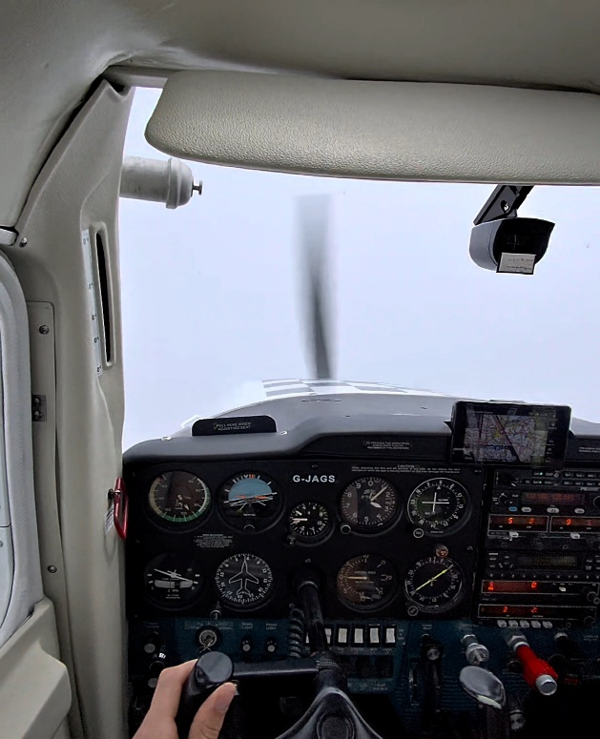
I officially started my flying training on the 29th of May at Gamston Flying School on the C150! My first part of training focused on basic handling skills, radio procedures and calls, and all the necessary skills and knowledge required prior to going solo. At first, this was quite challenging, especially since Gamston Airport has a slightly different circuit due to noise abatement procedures and since my instructor was constantly pushing me to do all the different radio calls and procedures (which was quite daunting at first); however, I progressed through all the required lessons and exercises quite quickly to a point at which I was ready to go solo at just 8 hours! Unfortunately, the weather at the point at which I was ready to go solo was above the maximum wind limits for solo student flying, which meant I had to wait for a period of better weather where the winds were much nicer. However, instead of wasting time waiting for such conditions to come, as we would lose about a week and a half, my instructors recommended that we complete the remaining exercises in the meantime.
Flying through clouds!
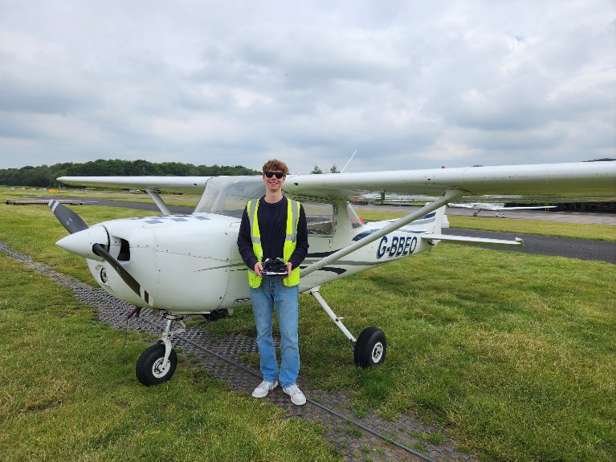
Eventually, the good weather came back, and I was finally able to go solo! I still remember to this day that first solo feeling; it was an absolutely incredible experience, and it is something that you will remember for the rest of your flying career! Since I was progressing through all the lessons and exercises quite quickly, I ended up being a few hours below the recommended amount for the next section of training, navigation and cross-country flying. This meant that when I came back down from my first solo circuit, my instructor asked me how I felt and whether I wanted to stay up a bit longer in the air and build up my hours!
Me after my first solo!
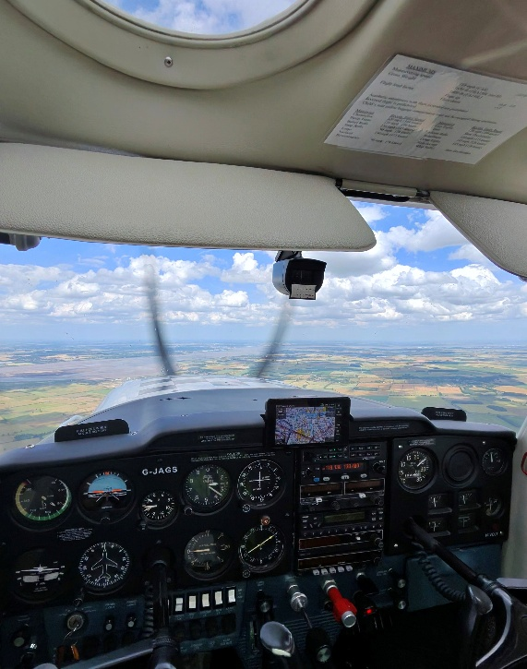
The next part of my training was developing my navigation skills, which once again sounded and looked quite scary at first since I was flying away from my home airfield, having to do a lot of new things and learn even more radio procedures and calls. This work was quite demanding, however, also equally rewarding, as I quickly gained accuracy and consistency and progressively expanded my spare mental capacity through these flights. How this section of training looks is that you will do the routes first with your instructor, and then do them again; however, this time, all by yourself solo. My very first navigation route was to Newark, then Mansfield, and back to Gamston, and this included talking to Waddington Radar and getting a Basic Service from them. The next route that followed that was to Humberside Bridge, to Goole and then back to Gamston, and this route also included getting a Basic Service, but this time with Humberside Radar. Last but not least, the final route I had to do was a transit through East Midlands Airport’s Class D airspace by flying to Nottingham Tollerton, to Carsington Water, and then back to Gamston. By far out of all these routes, the East Midlands Zone transit was the hardest, especially since you had to make sure you did not climb above 3,000 feet while maintaining 2,900 feet. When I did that route, it was very thermic, and I constantly had to make sure the aircraft did not climb. After the zone transit flight, I really appreciated how much mental capacity was required and was amazed at how much I had to manage simultaneously while flying accurately.
Cross-country to the Humber Bridge!
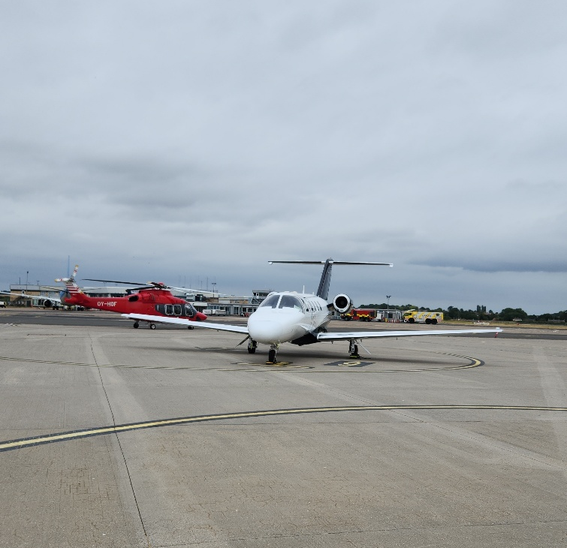
Following some more solo hour building, where I had the chance to see how much of an impact hot temperatures have on aircraft performance, I moved on to preparing for my QXC. The QXC is a required solo flight where you must fly a distance greater than 150 nm and land at two different airfields. For me, this QXC was from Gamston to Peterborough Conington, then to Humberside Airport, and then back to Gamston. The QXC is basically the same as the solo navigation flights, but over a larger distance. For me, this was definitely one of the highlights of my PPL journey, as I got to fly through both RAF Wittering’s and RAF Coningsby’s airspace, where I got to see German and RAF Typhoons flying and landing right next to me, and get to land at Humberside, which is an international airport, and park right next to private jets, large helicopters, and a TUI 737. I remember how out of place I felt flying in and parking next to these large, multi-crew aircraft and helicopters! Overall, the QXC was a demanding experience, but also equally exhilarating!
Humberside Airport on my QXC!
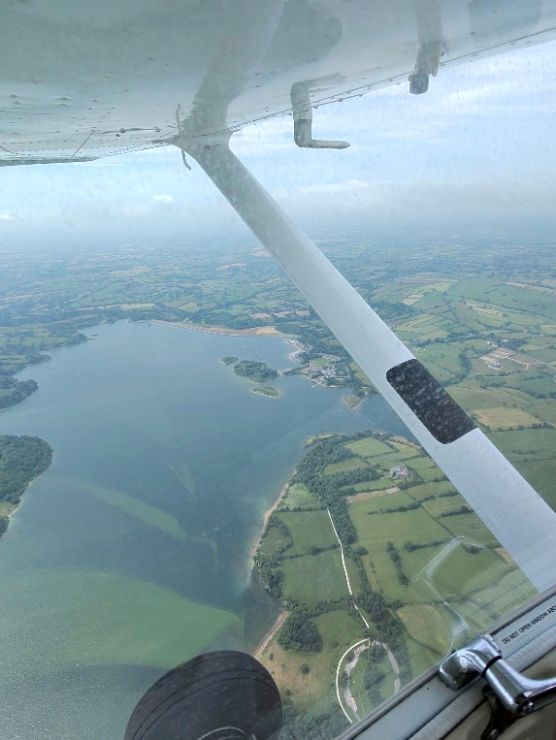
Finally, I moved on to the preparation and completion of my skills test. As the name suggests, it is a test where everything you have learnt is tested; this includes things such as steep turns, radio navigation, simulated instrument flying, and recovering from stalls. It is also the final practical assessment you have to complete before you can apply for your licence. On the 30th of July, I officially sat my test, and 2 hours and 15 minutes later, I was ecstatic to pass, meaning that I had completed my PPL in just over 41 hours!
Over the course of the entire practical flight training phase, I completed all of my theoretical examinations, which I am proud to have done all on my 1st attempt and with an average of 95%! In addition, I also completed and passed the RT practical exam, gaining my Flight Radio Telephony Licence (FRTOL), which allowed me to confidently manage radio communications throughout solo navigation and the skills test.
Flying through the Peak District!
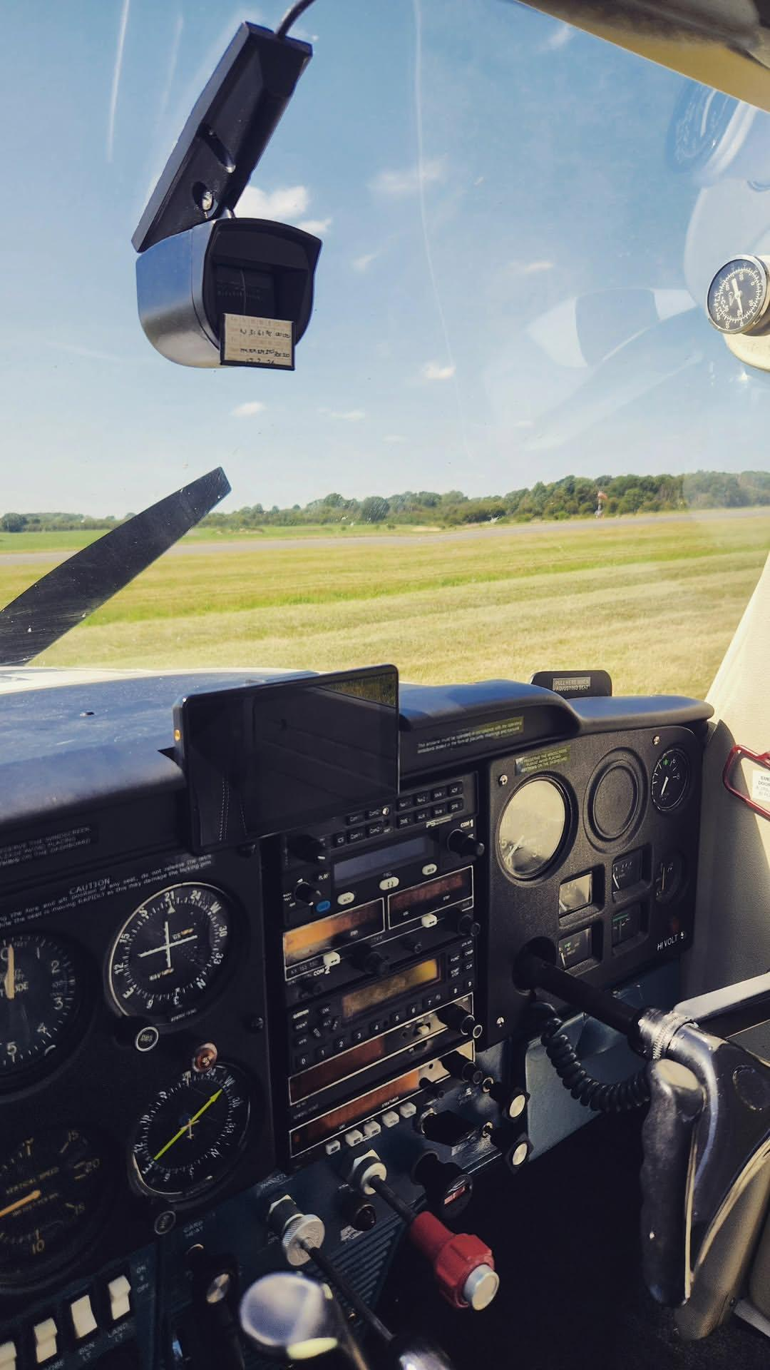
Reflecting back on the summer, I am incredibly grateful for all the amazing opportunities I have had and all the various successes I have achieved. This entire journey has been nothing short of extraordinary, from being ready to go solo at just 8 hours, to flying solo over 150 nm and in a wide range of conditions, to officially becoming a qualified pilot at just 17 (and among the top 5 youngest PPL(A) pilots at the time of getting my licence on the 21st of August 2026), I still cannot believe it! Becoming a qualified pilot in just 2 months has not been easy, especially at such a young age, but it most definitely has been very rewarding! I will most definitely remember this journey and summer forever!
I would also like to thank The Honourable Company and the BALPA Benevolent Fund for awarding me such an amazing opportunity to pursue my dream; I am forever thankful! This opportunity has allowed me to develop greatly by not only helping me achieve my dream of becoming a pilot, but also developing my confidence, discipline, and determination, which will ultimately serve me for the rest of my career. I cannot wait to be part of such a fantastic organisation! Another huge thank you to Martin and Tilly Watts, who greatly helped me with their advice and support throughout the whole application process; I owe them a lot!
Thank you to my buddy, Mollie Wadsworth, who has been nothing but amazing with all the help and support, and for always being on hand to answer my questions and to check in with me about my progress throughout my PPL training! I would not have been able to complete this scholarship as efficiently and quickly without her!
Finally, a huge thank you to everyone who has supported me throughout the whole application and training process!
I cannot wait to see what my future aviation career holds!

